

**CS 319 - Object-Oriented Software Engineering**

**Project Analysis Report**

**LOST**

**GROUP 2-D**

Eren Bilaloğlu - 21401603

Gunduz Huseynli - 21402821

Onur Sönmez - 21300749

Yasin İlkağan Tepeli - 21301707

Table Of Contents

**1. Introduction**3

**2. Overview**3

2.1 Gameplay 3

2.2 Characters 4

2.3 Map and Zones 8

2.4 Items 10

2.5 Events 16

2.6 Rules: 20

**3 Requirements**21

3.1 Functional Requirements 21

3.2 Non-Functional Requirements 22

**4. System Models**

[4.4.1 Main Menu Mockup Screen 39](https://docs.google.com/document/d/1hWJpUp6z4Rlg0ZrKZzIBcW9MrYc7GbEyHcqBAAUl124/edit#heading=h.7x8bssuphevp)

[4.4.2. Play/ Load Game Mockup Screen 40](https://docs.google.com/document/d/1hWJpUp6z4Rlg0ZrKZzIBcW9MrYc7GbEyHcqBAAUl124/edit#heading=h.wzw43bz7m7f5)

[4.4.3. Settings Mockup Screen 41](https://docs.google.com/document/d/1hWJpUp6z4Rlg0ZrKZzIBcW9MrYc7GbEyHcqBAAUl124/edit#heading=h.a00obpjhlq6v)

[4.4.4. Help Mockup Screen 42](https://docs.google.com/document/d/1hWJpUp6z4Rlg0ZrKZzIBcW9MrYc7GbEyHcqBAAUl124/edit#heading=h.yj8vjzlhvax5)

[4.4.5. Credits Mockup Screen](https://docs.google.com/document/d/1hWJpUp6z4Rlg0ZrKZzIBcW9MrYc7GbEyHcqBAAUl124/edit#heading=h.qu3spyimg62n)  43

4.4.6 Icons 44

**5. References** 49 23

## ***1. Introduction***

You wake up to the sounds of the owls, in a forest. The parts of the plane you were on a few hours ago are scattered around you. Some of the parts are still burning, illuminating the darkness around you. Mysteriously there is not anyone around. Not even the bodies. As you try to remember how last night’s accident happened, you try to understand whether you are on a stranded island or not.

LOST is a text based desktop game which allows players to dive into a story about surviving after a plane crash in a mysterious island and interact with the island itself. The story begins when player wakes up and finds himself among the burning ruins of the plane. However he does not succeed in finding any bodies, dead or alive. The player needs to build a fire, a shelter and gather useful items, craft them and get food and drink to survive in the island. While trying to do all of these, player will also need to discover the island and unravel the mysteries of the island, as he/she will meet new characters.

## ***2. Overview***

LOST is a text based survival game with primitive Graphical User Interface (GUI), designed for Windows and Linux desktop machines. After starting the application, user will see the main menu screen where he/she can start a new game, load a saved game (if there is any), change settings of the game, see top ten high scores or visit the wiki page of the game online to get help. User will be able to pause and resume game, and save the game on local storage at any time during the game.

### ***2.1 Gameplay***

Player will start in the middle of the forest, right after a surviving a plane crash. However, unfortunately he will also need to survive through the island and get to safety as soon as possible. Throughout the game, time will be measured with days, and high score will also be based on how many days it took the player to survive the island. Time will only pass when the player carries an action. First day, will be a tutorial in the initial area, showing the player how to interact with objects around him, how to craft items, and get food and drink and recover his energy. The island, which story takes place, is consisted of 9 main areas, which vary from each other. Player will be able to navigate through the areas via using navigation arrows on the screen or by pressing according keys (w(north), a(west), s(south), and d(east)). Each area will contain various items for the player to use, craft, or interact with, alongside with different characters. These characters will include a few mysterious persons helping the player or attacking him. Additionally areas will contain wild animals that player can hunt or be a pray for.

### ***2.2 Characters***

Characters in the LOST game will include Player, other humans and some animals.

***2.2.1 Player:***

Player will have an inventory, that he can add to or remove items from. Additionally, Player will have a health, hunger, thirst, and energy stats that will show his status during the game. In each area player will be presented with a menu to perform certain actions. Player will be able to choose from the options by simply typing the according number or by clicking on them:

1.View: Player will choose this option if he wants to view the objects and characters in the area, so he can interact with them. Choosing this option will result in a display of a sub-menu.

1.1.View Objects In The Area: This option will show a list of items in the area, so player can choose one of them by clicking. Doing so will present the actions of the item that player can use in a menu. Usually actions will be consisting of looking at the item, taking the item and adding it to the inventory, consuming and crafting the item.

1.2.View Objects In The Inventory: This option will behave in the similar way as the first option. However, the listed items will be from the player’s inventory.

1.3. View Characters In The Area: This option will show a list of characters that exist in the area. By clicking one of them, player will be shown a list of actions specific to chosen character. Such actions might be looking at the character, attacking it, and looting it if the character is dead.

2.Make a campfire: This option will be shown if there is no campfires in the current area. Making a campfire will require an item that player can start the fire and an item to feed the fire.

3.Sit at campfire: This option will only be available if there is a campfire lit by the player in the area. Choosing this option will show up a sub-menu:

3.1. Cooking: This option will show a list of meals and items that can be cooked. Cooking will increase the amount of hunger and energy recovered by consuming the food.

3.2. Boiling Water: This action will allow player to boil water, if there is any in the inventory. Boiling water will make it safe to drink.

3.3. Rest: This action will show up a sub-menu on the screen

3.3.1. Rest for 1 hour: This will recover energy slightly

3.3.2. Rest for 4 hours: This will recover some energy

3.3.3. Sleep for 8 hours: This will recover player’s energy considerably

3.4. Build A Shelter: This option will be seen if there is no shelter in the current area. A shelter will allow player to recover more energy from resting, and protect the player from rain.

***2.2.2 Other Characters:***

Player will meet with other human characters in the game as well. Player will be able to interact with characters according to his/her decisions. These characters will have their own health status, and they will be able to act hostile towards the player. Player can attack these characters with suitable weapons (item). If player kills the character, he/she can loot the body to acquire some items from the character’s inventory. Player can also acquire some items from the character as a gift simply by befriending him/her.

2.2.2.1 Wise Old Man: This character will have a very high health and high damage rate. So attacking this character will mostly result in the player’s death. As a result player should interact with this character to enter a story.

2.2.2.2 Volcano Dragon: This character will be faced once player manages to enter the volcano located in one of the distant areas on the map. Dragon will have a high health and damage rate as well. To defeat the dragon and ride it player will have to gather some quest items first.

***2.2.3 Animals:***

There will be various animals in the island in specific areas. Each animal will have their according health status and some of them will be able to attack back and deal damage once disturbed. In the case of being killed they will drop some items for the player to pick up.

2.2.3.1 Fish: Fish will be one of the prominent animals in the island. To catch fish player will need to craft a fishing rod or a spear. By catching fish player, will acquire 1 raw meat.

2.2.3.2 Deer: Deer will be one of the passive animals in the area. Killing a deer will be hard since, it will be able escape if the player fails to kill it in a few attacks.

2.2.3.3 Black Bear: Bears will be able to attack back once attacked by the player. They will also very rarely attack the player if they exist in the same area.

2.2.3.4 Polar Bear: This kind of bears will deal more damage than the black bears. They can be found in arctic zones of the island.

2.2.3.5 Boar: This wild animal in the island will be available for the player to hunt them. However, they will attack back dealing slightly damage to the player.

2.2.3.6 Pig: Pigs can be found near the abandoned village. They are harmless to the player.

2.2.3.7 Frog: Frogs can be one of the last resorts to recover some hunger if needed.

2.2.3.8 Crab: Crabs will be found in the swamp area of the island. They will not deal damage to the player once attacked.

2.2.3.9 Seal: Seals are one of the rarest animals in the game, living in the arctic zones. They will have a high health, and also will be able to deal some damage to the player.

2.2.3.10 Penguin: Penguins will live in the arctic zones as well. Although they will not be able to attack back, they will escape easily once attacked.

2.2.3.11 Bird: Birds will be available for hunting in the forest areas.

2.2.3.12 Exotic Birds: A kind of bird that lives in the jungle

2.2.3.13 Tiger: A wild animal that will threaten the player with its

existence, since it has high damage rate.

2.2.3.14 Monkey: A harmless animal that can be hunted, which lives in the jungle.

2.2.3.15 Rhino: A dangerous animal that has a high health and damage that lives near the swamps.

2.2.3.16 Wolf: An average predators of the island.

2.2.3.17 Fox: A predator that can both attack back or escape once attacked by the player.

2.2.3.18 Owl: The sacred animals of the forest. Can not be attacked by the player.

2.2.3.19 Rabbit: A perfect animal for hunting with low health and no damage.

2.2.3.20 Squirrel: Squirrels will live in the forest. They can also be hunted easily for food.

2.2.3.21 Snake: A dangerous animal that can poison the player, causing significant damage to the player’s health over time.

### ***2.3 Map and Zones***

One of the major parts covered on “LOST” is map structure that indicates the position of user. User can observe his/her position by opening the map section on menu. In main menu, all arrow keys specifying the possible movements of user will be arranged according to the position on the map. In this case, there will be restricted zones which mostly refer to the sea and if the user arrives the seaside, arrow keys will relatively end up. For example, left arrow will disappear if the user located in the left part of map. The map includes several zones defined by the distribution of geographical formations, plant cover and climate conditions.

***2.3.1 Target-specific observation:***

Just like in most of strategy games, “Lost” will provide target-specific observation. It means the area where the user located will be lightened up in a particular range. Other parts of map will be darkened and whenever the user changes his/her position, these parts start to be lightened up. The concept of game aims to thrill and bother the user during all the game. At the beginning, user does not know where he is and just walk away from the accident that drags him into mysterious area.

***2.3.2 Various Zones/ Districts:***

In the map, there will be domain-specific items, characters and events bounded by areas. Also all zones will contain a certain amount of items that are identical for only these areas. So if the user picks up and uses these items, the amount will be decreased and there will be a repair/renewal process that requires a specific time.

**Forest**: Forest is the location where the player borns at the beginning. That is why the difficulty level of the forests is low. They contain items and have various meek animals instead of dangerous ones.

**Jungle:** This part is more challenging than forests that the user located at the beginning. Productive lands with some wilderness.

**Dark Forest:** Dark forest is most hazardous part of forests. Includes wildest animals, various items and unexpected events that can be encountered.

**Mountain:** Mountains are one of the minimal occupancy areas in Lost.Theyinclude specific items like rock, stones, bushes, etc. Also wild animals like bear can be rarely encountered inside this area.

**Abandoned Village:** There are lots of traces that point human existencein long time before. Tents, used items can be found in this area.

**Beach:** Includes specific items which cannot be found in other areas which covered on beach items section.

**Volcano Zone:** This area is fulfilled with death bodies. The view totally points the wilderness in this area! Player should not rove around this area if he/she does not trust on his/her power and items.

**Swamp:** Geological formation of this area poses a threat for player to sink under the land.

But there will be several worthy elements that direct user to take the plunge.

**Iceland:** This land is leanest area in the map. It includes rare items and some wildest animals.

**Seaside:** All island is surrounded with sea, so in coast areas there will be a chance to catch a fish and nourishment. Additionally player will be able to gather locations specific items such as moss, salty water. Since most of areas have shores, they will include the Seaside specific functions and items. Also they are the boundaries of map.

### ***2.4 Items***

Items are the tools that help player to survive throughout the game. These items can be to strengthen or heal the character, maintain the health situation and open alternative ways and endings. Also player will need some tools to continue on the story. Items will be acquired according to the area where player is. If character is next to sea, he can catch fishes by using fishing rod. The last and the most important feature is crafting. Player can combine most of the items with each other and items are also breakable to get more basic items.

**2.4.1 Simple Items According to Areas:**

Items will drop or be found according to the areas.

**2.4.1.1 Forest Area:**

Forest items are mostly the things which you can find in jungles. Wood, stone, branch honey, metal trashes, old clothes and ropes are some of them. Also from jungle animals player can get meat and milk.

Tree, Bush, Stone and Grass: They are used in crafting.

**2.4.1.2 Mountain Area:**

Mountain area has two sub areas. In one of the area there is more water, so there will be moss and dirty water. Other area is full with hills so, player can find many stones and rocks there.

Rock, Stone, Bush and Moss: They are used in crafting.

**2.4.1.3 Volcano Area:**

In volcano area, near the Volcano there can be corps and the rest of the area consist dry trees and stones.

Dry Tree, Stone: They are used in crafting.

Corps: Player can examine and find items from the corps or carry them to complete the Story “Wise Old Man”.

**2.4.1.4 Jungle Area:**

In jungle area, you can find some wild fruits and basic items which can be found in every forest.

Tree, Stone, Bush, Branch: They are used in crafting.

Berry: Player can get rid of hunger by eating berries.

**2.4.1.5 Dark Forest Area:**

In dark forest area, there are many dark trees which can be used in heavy crafting.

Dark Tree, Stone, Branch: They are used in crafting.

**2.4.1.6 Abandoned Village Area:**

From this very old village, one can find many mushrooms. Also there are many stones in the village which are planned to be used but never used.

Stone, Metal Pieces and Grass: They are used in crafting.

Mushroom: It will help character to have less hunger but it is not effective as the others.

**2.4.1.7 Beach Area:**

Beaches are full of sand, glass pieces and little rocks. Also player can find little bit of meat from little crabs. Also time to time there can be glass pieces.

Sand, Rock Pieces and Glass Pieces: They are used in crafting.

**2.4.1.8 Swamp Area:**

Beaches are full of sand and little rocks. Also player can find little bit of meat from little crabs. Also time to time there can be glass pieces.

Moss: They are used in crafting.

**2.4.1.9 Seaside:**

Most of the areas include sea since they are next to sea. The items you can get from sea are fish, salty water (cannot be drinkable), moss, some wet wood pieces and etc.

Fish: Used to get rid of hunger.

Salty Water: Used to get rid of thirst but first it needs to be boiled with fire.

Moss and Wet Wood Pieces: Used in crafting.

Wrecked boat: It can be used to go home as soon as it is repaired.

**2.4.2 Items from Events:**

After completing an event such as killing an animal or looking at a special area like cave, tent, bear lair; player get special items from them to complete the game and survive.

Bear skin (fur): When player kill a bear character gets a fur from the dead bear. It will be necessary to complete the “Is There Anybody Out There?”

Metal wires: It can be found in the cave and it is used to repair the radio tower.

Radiotelephone: It can be found in tents from the Abandoned Village area. It will be used in the radio tower.

Dark Diamond: It can be found in bear’s lair or by killing an animal in dark forest. It will be used in “Dance with Fire” Story.

Ship Map: It will be found from the old man in Dark Forest.

Dragon Armor: It will be found from the cave in the mountain and it will be used in Story “Dance with Fire”.

Sail Machine: It will be found in the tent in the Abandoned Village and will be used to craft Sail.

Raw Meat: Player can get meats by killing the animals.

Polar Meat: It can be found when Polar Bear is killed and player needs to take it to the Old Wise Man to progress in Story “Wise Old Man”.

Medicine: Player gets from the crashed plane at the beginning of the game and he can also find from the tent in the Abandoned Village. It will drastically increase the health and energy.

**2.4.3 Advanced Items:**

These are the items which are made by crafting the basic items.

Knife (Stone + Rock Pieces/Stone): It is used to cut animals to get meat from them.

Wood (Tree + Axe): By cutting the tree you can get this basic item also.

Rope (Moss + Moss): Used in crafting.

Meat (Animal + Meat): It will help to get rid of hunger.

Cooked Meat (Fire + Meat): It is more powerful than raw meat.

Spear (Stone Pieces + Wood) : Having this increases the attack power.

Axe (Stone + Wood): You can find woods by cutting trees.

Hammer (Stone + Wood): Used in crafting.

Sword (Stone*2 + Metal Pieces*2): It will increase the attack points and also be used in the Story “Dance with Fire”.

Shelter (Wood + Branch + Stone + Ropes): It gives player health, power and ability to protect him.

Pure Water (Fire + Dirty/Salty Water): Used to get rid of thirst.

Bandage (Cloth pieces/moss + Cloth pieces/moss): Used to heal the character.

Fire (Branch + Metal Pieces/Glass Pieces/Rocks): It can be used to cook or warm the player.

Torch (Wood + Fire): You can stay away from dangerous animals with this. It increases defense points.

Fishing Rod (Stone Pieces + Rope): Helps to catch fishes.

Boat (Wrecked Boat + Wood + Hammer): Helps to go home and survive.

Armor (Cloth Pieces + Metal Pieces*2 + Stone): It will increase defense.

Sail (Grass + Sail Machine): It will be used to complete the ship in the Story “Sailing Away”.

**2.4.4 Basic Items from Items:**

These items are the result of a destruction of an item.

Stone Pieces (from Stone): Used in crafting.

Cloth pieces (from Corps): Used in crafting.

Nails (from Metal Pieces): It is used in crafting. It is necessary to repair the ship.

### ***2.5 Events***

**2.5.1 Interaction Events:**

This type of events will form the biggest part of the gameplay. Single interactions that player will make with a character or an object will be considered as an interaction event. For example; crafting a wood, speaking with a character, fighting with an animal will be some of the interaction events that player can perform. On the main screen, objects or characters that are located near player at that moment will be listed so that player can select and interact with them. When player clicks on an object or character, a simple menu that will show the possible types of interaction with that item/character (e.g. craft, collect, throw, speak, fight, etc.) will be opened. Each item can have different types of interaction selections. For example, a wood can be crafted, collected, fired whereas a lake can offer interactions such as swim, drink water, fishing etc. This is also true for characters. Some characters will be attackable while some of them will offer only friendly interactions. Player can interact with items or characters by clicking on the interaction type as he/she selects.

**2.5.2 Story Events**

Story events will consist of series of tasks that promise survival from the island. To complete the story events, player will have to fulfill all the tasks in the event's scenario. Player will be able to join this type of events by completing particular milestones, such as collecting all the parts of a puzzle or finding a mystic item, or interacting with special characters. Shortly, an interaction event or result of an interaction event/events may result in entering a story event. Before entering a story event, player will be informed with a text message on the screen that asks him/her if he/she wants to enter this event. If player clicks yes and he/she fulfills the requirements of the story event, player enters the story mode. Once he/she enters a story event, player will not be able to perform operations outside of the event's scenario until he/she completes it or quits without completing the event (this may result in some losses).

**Story Event 1:** Is There Anybody Out There?

There will be a broken radio tower in the iced area. When player find a map that shows the location of the tower, a text message will pop up that asks player to if he/she wants to enter the story event or not. The goal of this story event is repairing the radio tower and sending a message to the outside world via a radiotelephone. If player completes this story event, he/she survives from the island.

The requirements for entering this story event will be the following:

-60+ HP

-At least 8 days in the island

-Bear skin (fur)

Tasks will be the following:

1) Going to iced area and seeing the tower

2) Going to cave and finding metal wires for repairing the tower

3) Repairing the tower (this will take two nights, so player will have to be prepared for staying two nights in the iced area)

4) Searching the tents in the abandoned village for a radiotelephone

5) Finding the correct channel by solving a riddle

6) Sending the message

Player will encounter several difficulties while doing the tasks. These includes wild animals, misleading clues or characters.

**Story Event 2:** Dance With Fire

A dragon lives in a volcanic area of the island. When player visits there, he/she will face with terror of the dragon. Dragon will attack to player and if player manages to escape, a text message will pop up that asks player to if he/she wants to enter the story event or not. The goal of this story event is finding a diamond that makes dragon controllable so that player can ride it and fly away from the island. If player completes this story event, he/she survives from the island.

The requirements for entering this story event will be the following:

-60+ HP

-A dragon armor

-A sword

-At least 15 days in the island

Tasks will be the following:

1) Finding the dark diamond in the forest. Player will have to fight with the animals to see if any of them has the diamond and he/she will have to examine specific places (e.g. bear’s lair) for searching the diamond.

2) After finding the diamond, player will have to visit the volcanic area again and throw the diamond into volcano.

**Story Event 3:** Sailing Away

There will be a wrecked ship stands on the beach washed by the waves.When the player finds it, a text message will pop up that asks player to if he/she wants to enter the story event or not. The goal of this story event is repairing the wrecked ship and sailing away with it. If player manages to build a strong ship, he/she survives from the island.

The requirements for entering this story event will be the following:

-A hammer

-A knife

Tasks will be the following:

1) Getting 40 woods

2) Getting 20 ropes

3) Building a sail by using the grass and pieces from the tents

4) Finding a map that shows the route of the ship

5) Repairing the ship

Player will encounter several difficulties while doing the tasks. Repairing the ship will not be easy due to natural conditions of the island and mystery creatures that will try to prevent you sailing away.

**Story Event 4:** Wise Old Man

There will be a wise old man in the depths of the dark forest. If player finds him, a text message will pop up that asks player to if he/she wants to enter the story event or not. The old man knows a way for escaping from the island: teleportation. However, this comes with cost. Player will have to fulfill the requests of the wise old man in order to get help from him. If player fulfill all the requests of the wise old man, he/she will be able to survive from the island by teleportation.

The requirements for entering this story event will be the following:

-At least 10 days in the island

Tasks will be the following:

1) Player have to bring polar meat to the old man

2) Finding two corpses once belonged to old man’s family and returning them back to the old man (corpses will be heavy so the player will have to visit the volcanic area two times, which will take time and be dangerous)

### ***2.6 Rules:***

Player will die if his health reaches 0 in any scenario. Additionally if one of the thirst, hunger stats reaches 0, energy will start to drain slowly while one of the stated stats still remains 0. If energy reaches 0, health will start to decrease over time. As a result death can be caused by attack from a certain character or animal, or starving to death. When the player attacks a character or an animal, the opponent's health will be reduced by the player’s attack damage plus the damage of the item he is using to attack. If player could not kill his opponent in the first blow, the opponent might attack back, or try to escape.

In order to increase the thirst stat, player needs to consume liquid.

In order to increase the hunger stat, player needs to consume food.

In order to increase energy stat, player needs to rest.

Health can be increased drastically by taking medicine. Additionally, if the thirst, hunger, and energy stats are all above 60, health will increase slowly. Otherwise the health will remain same.

## ***3 Requirements***

### ***3.1 Functional Requirements***

**New Game:** Player can create a game which you start from scratch. Player will wake up in a forest with a few items in his inventory which will be determined according to what character he chooses in the settings. By answering questions and choosing directions he will try to survive from an island where he is now. It’s likely that player will be killed or dies from starvation. Note that when user closes the game it will be saved. Also when player click this option, the last saved game will be deleted.

Main purpose will be surviving by being careful about player’s health, hunger, thirst or the paths he chooses.

**Load Game:** If player played a game before and haven’t finished yet it will be saved. From this option he can continue his game from exact situation and with exact items.

**Settings:** This option will give player permission to customize your game a little bit. There will be 3 options:

**·Sound:** Player can mute the sounds which are sounds of forest, beach,

animal and characters.

**·Panel Size:** Player chooses from 2 options: Normal, Large.

**Help:** It includes the gameplay explanation. It shows how to combine or craft items and what you should do to survive from island. Also rules can be read from this option. An online wiki can be accessed from here for more information about the game.

**Records:** Player can see High scores (Top 10) and his position (also other scores close to player’s point) if he has internet connection. It will give a feeling of competition and it encourages people.

**Credits:** This option includes the contact information of the developers of game and also people who help the game during creation.

### ***3.2 Non-Functional Requirements***

**Extendibility:** Game will be implemented with an extendible design so that new features can be added without doing huge changes on legacy code from previous versions of the game. Object oriented design concepts will be employed to make easily extendible design.

**Maintainability:** Game will be coded in a maintainable manner so that programmers who want to contribute will not have difficulties understanding the implementation and design. Comments will be used to explain the code blocks where necessary.

**Usability:** Game will have simple and friendly user interface that helps users to easily comprehend the game basics. Control icons, names, keywords, sound effects will have real life metaphors to make users comfortable.

**Reliability:** Player’s game progress will be kept locally so that user can load his/her game and continue from where he/she left. Players’ records will be kept in an online database. These data (game progresses and records) will not lost because of a system failure or a power loss.

## 

## ***4. System Models***

### ***4.1 Use Case Model***

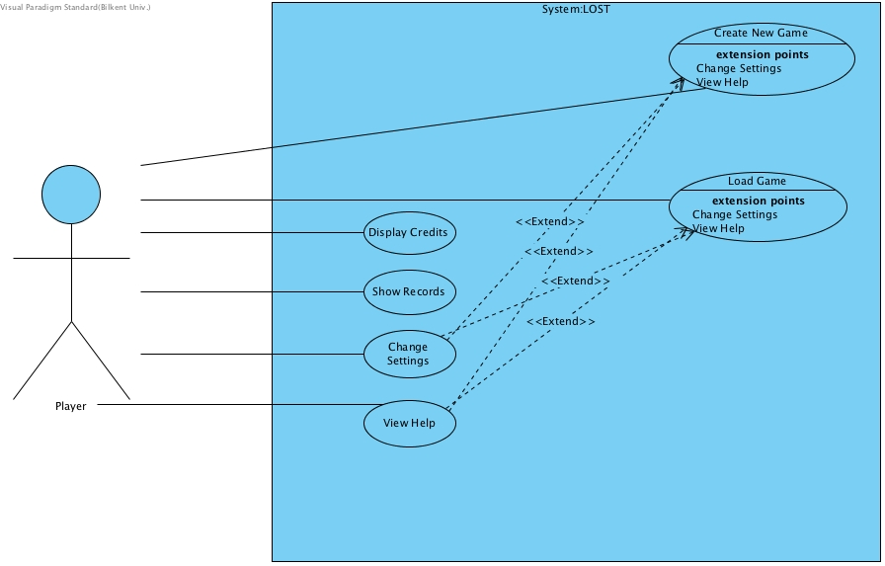

**Figure 4.1 - Shows the use case model of LOST**

**4.1.1 Use Case Descriptions**

**4.1.1.1 Use Case Name:** New Game

**Participating Actor:** Player

**Stakeholders and Interests:** Player may want to create a new survival game.

**Entry condition:** Player opens game and starts game by clicking relevant section.

**Exit condition:**

**•** Player return Game screen,OR

**•** Player dies, OR

**•** Player succeeds to survive and escapes from island.

**Main flows of events:**

**1.** Player starts the game.

**2.** System loads default settings and starts the game.

**3.** User enters a nickname.

**4.** Some guidelines end up on screen.

**5.** Player interacts with objects around him/her and uses them correctly.

**6.** Player completes the one of story events, achieve to survive.

**7.** The obtained score is demonstrated on screen at the end of the game.

**Alternative flows of events:**

**5.1.** Player does not use items correctly.

a.Thirst, starvation becomes high level and the healthiness of user starts to drop out.

b. Player dies because of misuse, deficiency of items.

**5.2.** Player uses items correctly.

a.Player handles with starvation, finding good supplies and health condition is good enough.

b. Player has troubles on interaction between objects, he/she always makes wrong choices in matches between characters.

c. Player dies because of enemy attack.

**5.3.** Player gets bored and may want to close the game.

a. The game instructions are loaded and whenever the user loads the game, player continues from the position where he/she left.

**4.1.1.2 Use Case Name:** Load Game

**Participating Actor:** Player

**Stakeholders and Interests:** Player wishes to continue previous uncompleted game.

**Entry condition:** User must have a record that he/she plays this game before and not completed yet. Player should click on load game button in main screen.

**Exit condition:**

**•** Player clicks on back button in Game screen,OR

**•** Player dies, OR

**•** Player succeeds to survive and escapes from island.

**Main flows of events:**

**1.** Player starts the game in recorded location.

**2.** Follows same steps defined new game use case.

**3.** Player successfully or unsuccessfully complete the game.

**Alternative flows of events:**

**3.** Player does not complete the game.

a. Game instructions are loaded again and waiting for next connection of player.

**4.1.1.3 Use Case Name:** Credits

**Participating Actor:** Player

**Stakeholders and** **Interests:** Player may want to review developers, contents and sources of game.

**Entry condition:** User clicks on “Credits” in main menu.

**Exit condition:** User returns on game screen.

**Main flows of events:**

**1.** System shows the text-based content for credits section.

**Alternative flows of events:**

**1.** Player wants to return back to the main menu.

a. Player come backs to the screen.

b. System renders main menu screen.

**4.1.1.4 Use Case Name:** Records

**Participating Actor:** Player

**Stakeholders and** **Interests:** Player can review the scoreboard and indicate competition between users.

**Entry condition:** User clicks on “Records” in main menu.

**Exit condition:** User returns in Game screen.

**Main flows of events:**

**1.** Player observes the scores of users and the leaderboard of game.

**Alternative flows of events:**

**1.** Player may want to return to main menu.

a. Player chooses returning back to the main menu screen.

b. System renders main menu screen.

**4.1.1.5 Use Case Name:** Settings

**Participating Actor:** Player

**Stakeholders and Interests:**

**•** Player wishes to close the sound effects.

**•** Player wishes to change the game panel size.

**Entry Condition:** Player has to be in main menu or the game must currently be started. Press Settings section in main menu.

**Exit condition:** User clicks on back button after reviewing the game settings.

**Main flows of events:**

**1.** Player picks availability of sounds and game panel size.

**2.** Press apply button.

**3.** Return to main menu/game.

**Alternative flows of events:**

**1.** Player may give up changing the game settings.

a. Player directly returns main menu/game without applying the changes.

**2.** Play may forget to apply the changes.

a. Previous system requirements become active in this case.

**4.1.1.6 Use Case Model:** Help

**Participating Actor:** Player

**Stakeholders and Interests:** User may want to be informed about features of game, understand the game mechanics and take sort of guidelines, hints about “Lost”.

**Entry Condition:** Player has to be in main menu or the game must currently be started. Player should open Help section in main menu.

**Main flows of events:**

**1.** User opens the game and in order to take guidelines of game, opens Help section.

**2.** Understand game mechanics and concepts.

**3.** Turns back main menu/game.

### ***4.2 Object and Class Model***

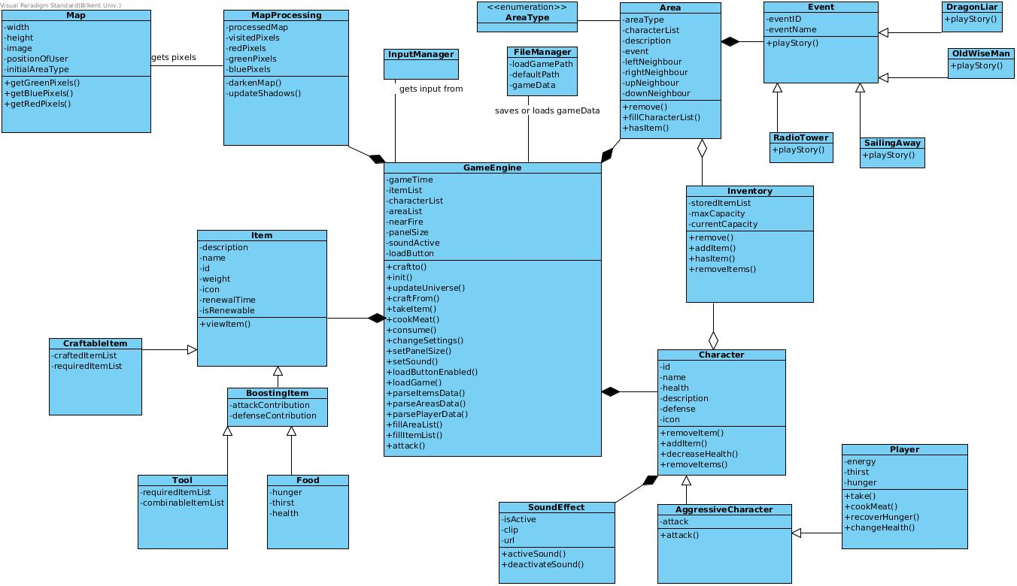

### 

### 

### 

### ***4.3 Sequence Diagrams***

#### 4.3.1 Changing Settings Scenario

#### settings.jpg

In this scenario, user is in the main menu screen, and decided to click on the change settings button. This results in displaying the change settings page. In here, user can change the panel size as he wants, or enable/disable the sound in the game

### 

### 

### 4.3.2 Loading A New Game

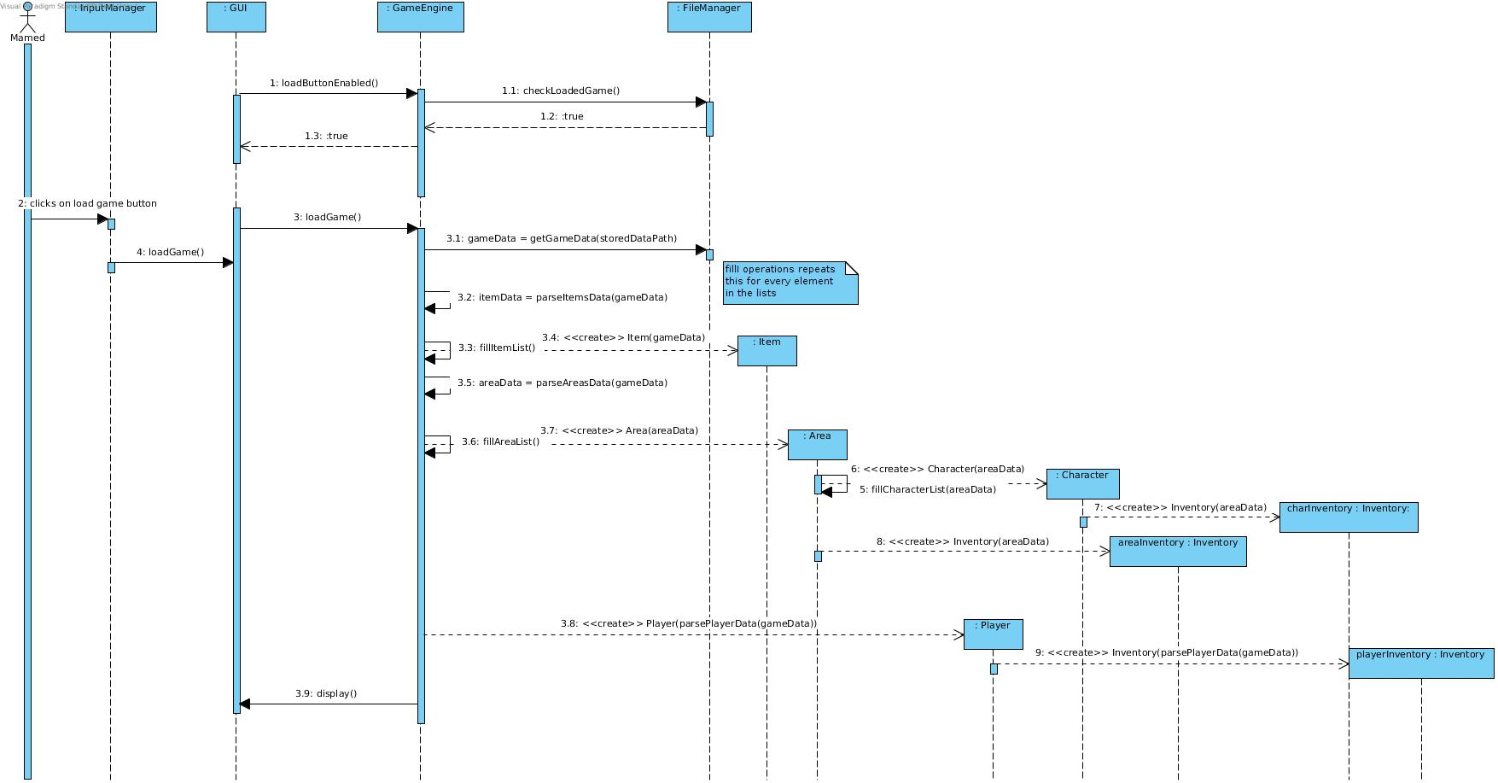

In this scenario, player chooses to load a previous game. This option is only available if there is a previously saved game in the local memory. If successful the game engine asks the file manager to get the data from a txt file and return it. After parsing this data accordingly, game engine passes it to the accordoing classes and creates them by doing so. The new game scenario is very similar to this one, as in that case data will be loaded from a default txt file

### 4.3.3

### Use.jpg

In this scenario, user takes a raw meat from the inventory of the area. Then he decides to sit at the campfire, which enables him to perform interactions that are specific to the campfire. Then, he decides to cook, and eat the meat which recovers his hunger.

### 

### 

### 

### 4.3.4

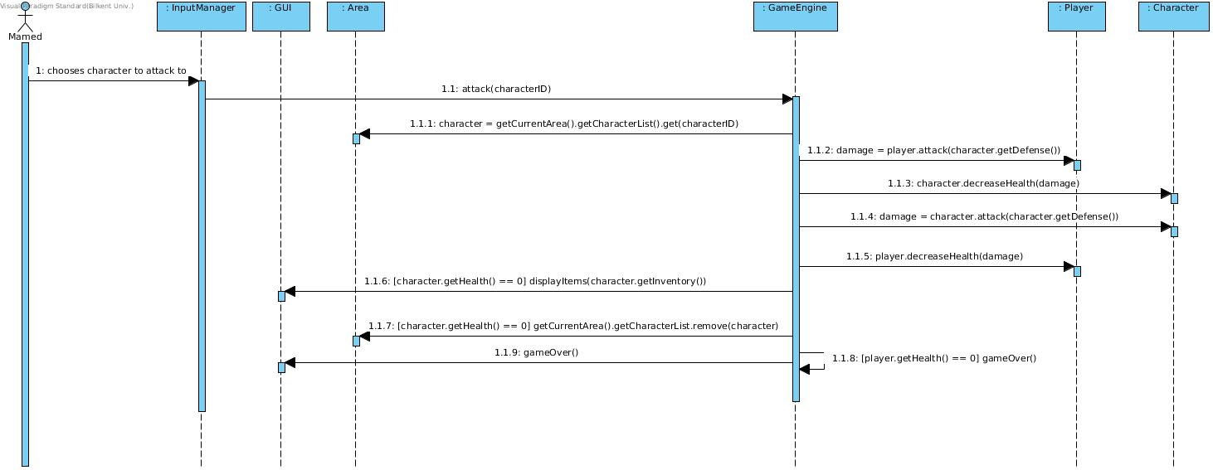

This scenario describes when a player chooses to attack another character. This scenario both applies to hunting and fighting other characters.

### 4.3.5

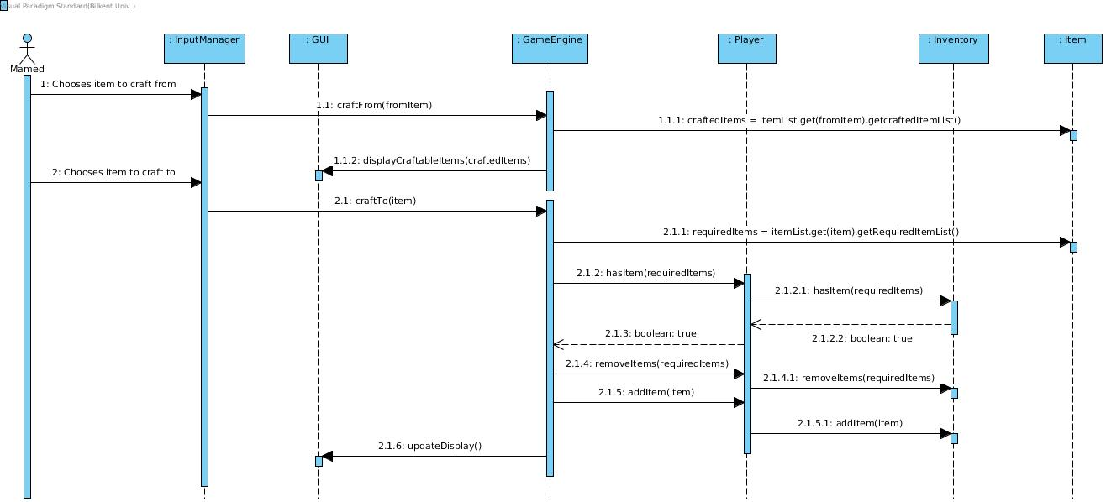

In this scenario, user chooses the item to craft from either from the inventory section or the main screen. This results in displaying the craftable items from that list. By choosing one of the items from that list, player adds that item to his inventory if he has the required items for crafting.

### 

### ***4.4 Screen Mockups and Icons***

#### 4.4.1 Main Menu Mockup Screen

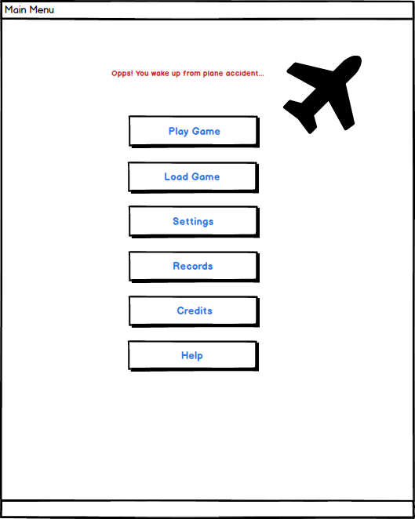

Lost will have simple game menu and it will have basic background.

#### 4.4.2. Play/ Load Game Mockup Screen

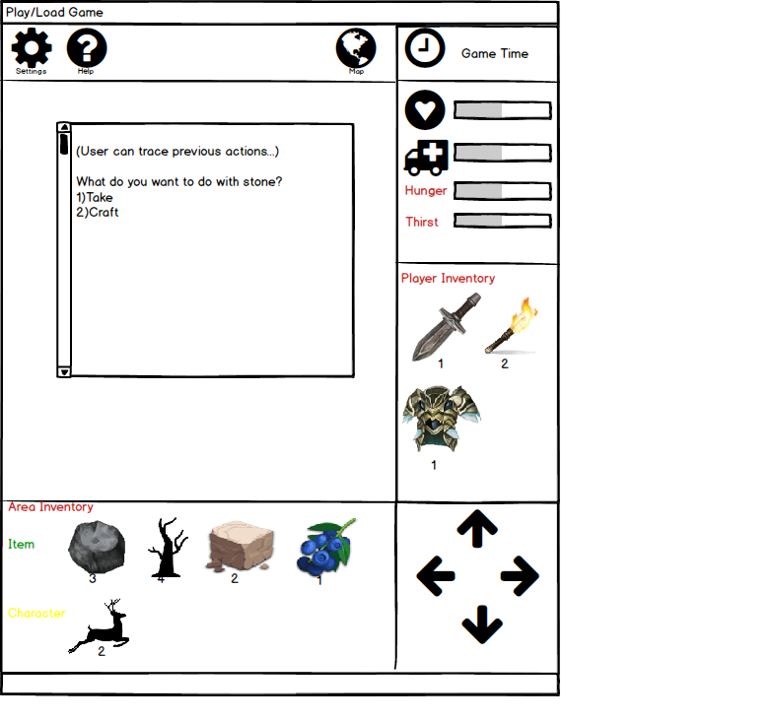

Upper section of screen enables user to access settings, help and map panels.Map will enable user to observe his/her location and it is possible to change the settings and display guidelines of game in help section.

#### 4.4.3. Settings Mockup Screen

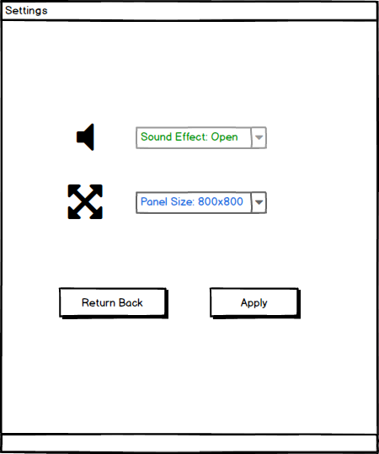

#### 4.4.4. Help Mockup Screen

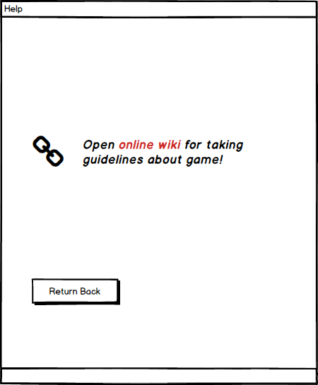

#### 4.4.5. Credits Mockup Screen

### 

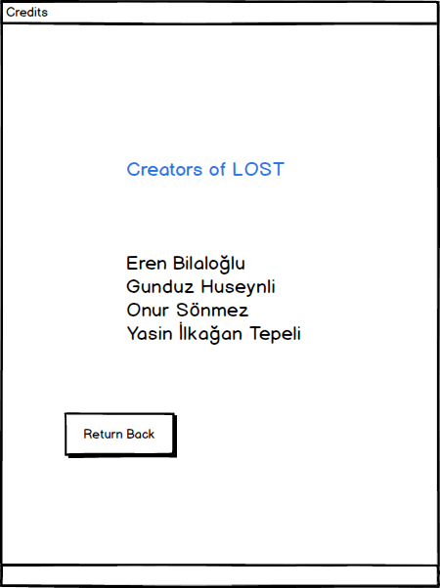

**4.4.6 Icons**

Tree: 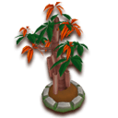1

Bush: 1

Grass: 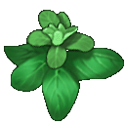3

Rock: 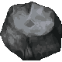3

Moss: 3

Stone: 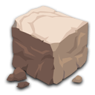1

Corps: 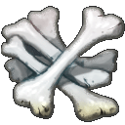3

Branch: 3

Berry: 1

Dark Tree: 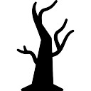4

Metal Pieces: 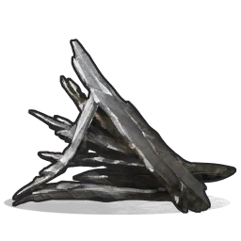5

Mushrooms: 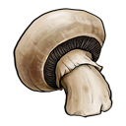1

Sand: 2

Rock Pieces: 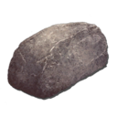2

Glass Pieces: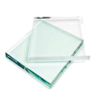2

Fish: 1

Salty Water:3

Wood: 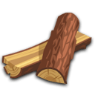1

Wrecked Boat: 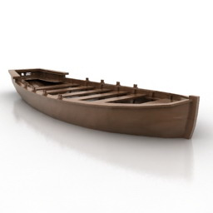7

Bear Skin: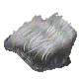3

Metal Wires:3

Radiotelephone: 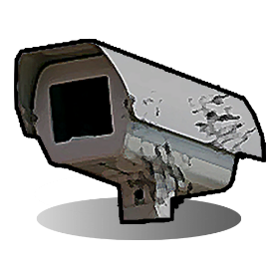5

Dark Diamond:3

Ship Map: 1

Dragon Armor: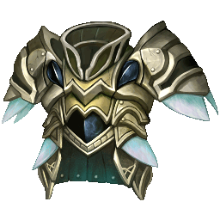3

Sail Machine: 6

Raw Meat: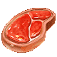3

Polar Meat: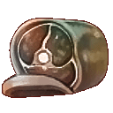3

Medicine: 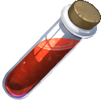3

Knife: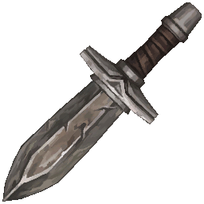3

Rope: 1

Cooked Meat: 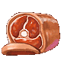3

Spear: 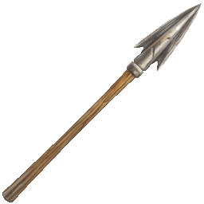

Axe: 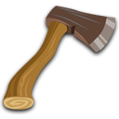1

Hammer: 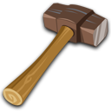1

Sword: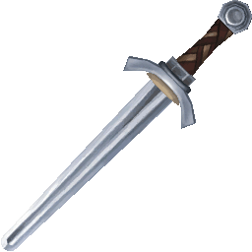3

Shelter: 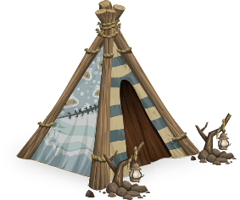6

Pure Water:3

Bandage: 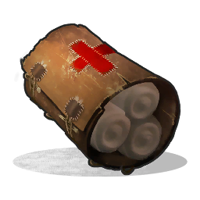5

Fire: 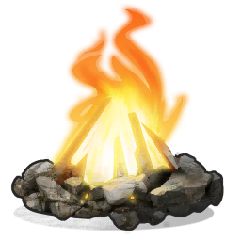5

Torch: 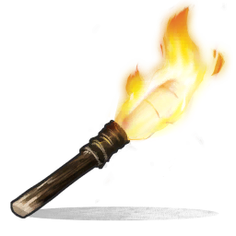5

Fishing Rod: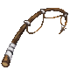3

Boat: 6

Armor: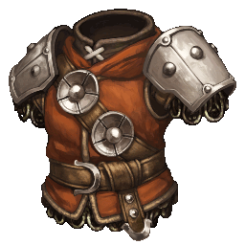3

Sail: 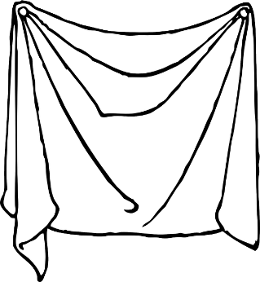6

Stone Pieces: 1

Cloth Pieces: 1

Nails: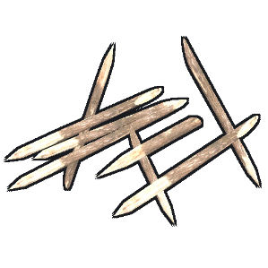5

***5. References***

1: <http://wikia.nocookie.net>

2: [https:// ark.gamepedia.com](https://hydra-media.cursecdn.com/ark.gamepedia.com/thumb/d/d4/Stone.png/128px-Stone.png?version=44043f3da05a3e1df87697074dec02dd)

3: [http://www.tosbase.com](http://www.tosbase.com/content/img/icons/items/icon_item_farm49_2_mq06_item2.png)

4: [https:// freepik.com](https://image.freepik.com/free-icon/halloween-dead-tree_318-77574.jpg)

5: <http://rust.wikia.com/wiki/Items>

6: <https://pixabay.com>

7: <http://archive3d.net>